Build HTML Pages

|  |  |
| --- | --- |
| Date | 06 Nov 2022 |
| Team ID | **PNT2022TMID40735** |
| Project Name | Virtual Eye - Life Guard For Swimming Pools To Detect Active Drowning |
| Maximum Marks | 4Marks |

# index.html

<!DOCTYPE html>

<html lang="en">

<head>

<meta charset="UTF-8">

<meta http-equiv="X-UA-Compatible" content="IE=edge">

<meta name="viewport" content="width=device-width, initial-scale=1.0">

<!--Bootstrap -->

<link rel="stylesheet" href="https://maxcdn.bootstrapcdn.com/bootstrap/4.0.0/css/bootstrap.min.css" integrity="sha384- Gn5384xqQ1aoWXA+058RXPxPg6fy4IWvTNh0E263XmFcJlSAwiGgFAW/dAiS6JXm" crossorigin="anonymous">

<script src="https://code.jquery.com/jquery-3.2.1.slim.min.js" integrity="sha384- KJ3o2DKtIkvYIK3UENzmM7KCkRr/rE9/Qpg6aAZGJwFDMVNA/GpGFF93hXpG5KkN" crossorigin="anonymous"></script>

<script src="https://cdnjs.cloudflare.com/ajax/libs/popper.js/1.12.9/umd/popper.min.j s" integrity="sha384- ApNbgh9B+Y1QKtv3Rn7W3mgPxhU9K/ScQsAP7hUibX39j7fakFPskvXusvfa0b4Q" crossorigin="anonymous"></script>

<script src="https://maxcdn.bootstrapcdn.com/bootstrap/4.0.0/js/bootstrap.min.js" integrity="sha384- JZR6Spejh4U02d8jOt6vLEHfe/JQGiRRSQQxSfFWpi1MquVdAyjUar5+76PVCmYl" crossorigin="anonymous"></script>

<script src="https://kit.fontawesome.com/8b9cdc2059.js" crossorigin="anonymous"></script>

<link href="https://fonts.googleapis.com/css2?family=Akronim&family=Roboto&display= swap" rel="stylesheet">

<link rel="stylesheet" href="../static/style.css">

<!-- <script defer src="../static/js/main.js"></script> -->

<title>Virtual Eye</title>

</head>

<body>

<header id="head" class="header">

<section id="navbar">

<h1 class="nav-heading"></i>Virtual Eye</h1>

<div class="nav--items">

<ul>

<li><a href="{{ url_for('index')}}">Home</a></li>

<li><a href="{{ url_for('login')}}">Login</a></li>

<li><a href="{{ url_for('register')}}">Register</a></li>

<li><a href="{{ url_for('login')}}">Demo</a></li>

</ul>

</div>

</section>

<section id="slider">

<div id="carouselExampleIndicators" class="carousel" data- ride="carousel">

<ol class="carousel-indicators ">

<li data-target="#carouselExampleIndicators" data-slide-to="0" class="active "></li>

<li data-target="#carouselExampleIndicators" data-slide- to="1"></li>

<li data-target="#carouselExampleIndicators" data-slide- to="2"></li>

</ol>

<div class="carousel-inner">

<div class="carousel-item active">

<img class="d-block w-100" src="../static/img/1.png" alt="First slide">

</div>

<div class="carousel-item">

<img class="d-block w-100" src="../static/img/second.jpg" alt="Second slide">

</div>

<div class="carousel-item">

<img class="d-block w-100" src="../static/img/third.jpg" alt="Third slide">

</div>

</div>

<a class="carousel-control-prev" href="#carouselExampleIndicators" role="button" data-slide="prev">

<span class="carousel-control-prev-icon" aria- hidden="true"></span>

<span class="sr-only">Previous</span>

</a>

<a class="carousel-control-next" href="#carouselExampleIndicators" role="button" data-slide="next">

<span class="carousel-control-next-icon" aria- hidden="true"></span>

<span class="sr-only">Next</span>

</a>

</div>

</section>

</header>

<section id="about">

<div class="top">

<h3 class="title text-muted">

ABOUT PROJECT

</h3>

<div class="line"></div>

</div>

<div class="body">

<div class="left">

<h2>Problem:</h2>

<p>

Swimming is one of the best exercises that helps people to reduce stress in this urban lifestyle. Swimming pools are found larger in number in the hotels, weekend tourist spots and barely people have in their house backyard. Beginners, especially often feel it difficult to breathe under water and causes breathing trouble which in turn cause a drowning accident. Worldwide, drowning produces a higher rate of mortality without causing injury to children. Children under six of their age are found to be suffering the highest drowning mortality rates worldwide..Such kinds of deaths account for the third cause of unplanned death globally, with about 1.2 million cases yearly.

</p>

</div>

<div class="left">

<h2>Solution:</h2>

<p>

To overcome the conflict, a meticulous system is to be implemented along the swimming pools to save the human life. By studying body movement patterns and connecting cameras to an artificial intelligence (AI)system we can devise an underwater pool safety system that reduces the risk of drowning. Usually such systems can be developed by installing more than 16 cameras underwater and ceiling and analysing the video feeds to detect any anomalies . but AS a POC we make use of one camera that streams the video underwater and analyses the position of swimmers to assess the probability of drowning ,if it is higher than an alert will be generated to attract lifeguards attention.

</p>

</div>

</div>

<div class="bottom">

<p ><b>

Note : The system is not designed to replace a lifeguard or other human monitor, but to act as an additional tool. “It helps the lifeguard to detect the underwater situation where they can’t easily observe.

</b></p>

</div>

</section>

<section id="footer">

<p>Copyright © 2021. All Rights Reserved</p>

</section>

</body>

</html>

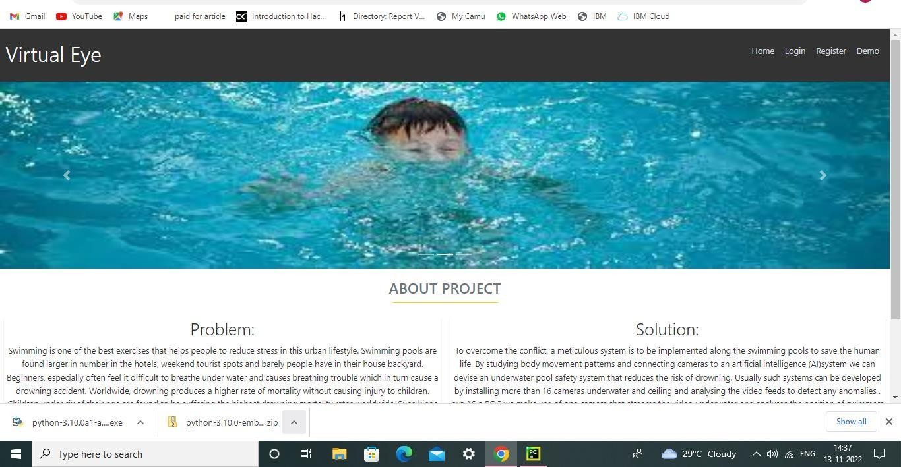

# base.html

<html lang="en">

<head>

<meta charset="UTF-8">

<meta name="viewport" content="width=device-width, initial-scale=1.0">

<meta http-equiv="X-UA-Compatible" content="ie=edge">

<title>High Quality Facial Recognition</title>

<link href="https://cdn.bootcss.com/bootstrap/4.0.0/css/bootstrap.min.css" rel="stylesheet">

<script src="https://cdn.bootcss.com/popper.js/1.12.9/umd/popper.min.js"></script>

<script src="https://cdn.bootcss.com/jquery/3.3.1/jquery.min.js"></script>

<script src="https://cdn.bootcss.com/bootstrap/4.0.0/js/bootstrap.min.js"></script>

<link href="{{ url_for('static', filename='css/main.css') }}" rel="stylesheet">

<style>

.bg-dark {

background-color: #42678c!important;

}

#result {

color: #0a1c4ed1;

}

</style>

</head>

<body style="background-color:black";>

<header id="head" class="header">

<section id="navbar">

<h1 class="nav-heading"></i>Virtual Eye</h1>

<div class="nav--items">

<ul>

<li><a href="{{ url_for('index')}}">Home</a></li>

<li><a href="{{ url_for('logout')}}">Logout</a></li>

<!-- <li><a href="#about">About</a></li>

<li><a href="#services">Services</a></li> -->

</ul>

</div>

</section>

</header>

<div class="container">

<div id="content" style="margin-top:2em">

<div class="container">

<div class="row">

<div class="col-sm-6 bd" >

<h2><em style="color:white;">High Quality Facial Recognition</em></h2>

<br>

<p><h5><i style="color:white;">Emotion Detection Through Facial Feature Recognition</i></h5></p>

<img src="https://130e178e8f8ba617604b- 8aedd782b7d22cfe0d1146da69a52436.ssl.cf1.rackcdn.com/facial-recognition-use- triggers-gdpr-fine-showcase_image-10-a-12991.jpg" style="height:240px"class="img-rounded" alt="Gesture">

</div>

<div class="col-sm-6">

<div>

<h4 style="color:white;">Upload Image Here</h4>

<form action = "http://localhost:5000/" id="upload-file" method="post" enctype="multipart/form-data">

<label for="imageUpload" class="upload-label"> Choose Image

</label>

<input type="file" name="image" id="imageUpload" accept=".png,

.jpg, .jpeg,.pdf">

</form>

<div class="image-section" style="display:none;">

<div class="img-preview">

<div id="imagePreview">

</div>

</div>

<div>

<button type="button" class="btn btn-info btn-lg " id="btn- predict">Analyse</button>

</div>

</div>

<div class="loader" style="display:none;"></div>

<h3>

<span id="result"> </span>

</h3>

</div>

</div>

</div>

</div>

</div>

</div>

</body>

<footer>

<script src="{{ url_for('static', filename='js/main.js') }}" type="text/javascript"></script>

</footer>

</html>

# register.html

<!DOCTYPE html>

<html >

<head>

<meta charset="UTF-8">

<meta name="viewport" content="width=device-width, initial-scale=1">

<title>Virtual Eye</title>

<link href='https://fonts.googleapis.com/css?family=Pacifico' rel='stylesheet' type='text/css'>

<link href='https://fonts.googleapis.com/css?family=Arimo' rel='stylesheet' type='text/css'>

<link href='https://fonts.googleapis.com/css?family=Hind:300' rel='stylesheet' type='text/css'>

<link href='https://fonts.googleapis.com/css?family=Open+Sans+Condensed:300' rel='stylesheet' type='text/css'>

<link rel="stylesheet" href="{{ url_for('static', filename='css/style.css')

}}">

<link href='https://fonts.googleapis.com/css?family=Merriweather' rel='stylesheet'>

<link href='https://fonts.googleapis.com/css?family=Josefin Sans' rel='stylesheet'>

<link href='https://fonts.googleapis.com/css?family=Montserrat' rel='stylesheet'>

<style>

.header {

top:0; margin:0px; left: 0px; right: 0px; position: fixed;

background-color: #28272c; color: white;

box-shadow: 0px 8px 4px grey; overflow: hidden;

padding-left:20px;

font-family: 'Josefin Sans'; font-size: 2vw;

width: 100%; height:8%;

text-align: center;

}

.topnav { overflow: hidden; background-color: #333;

}

.topnav-right a { float: left; color: #f2f2f2;

text-align: center; padding: 14px 16px; text-decoration: none; font-size: 18px;

}

.topnav-right a:hover { background-color: #ddd; color: black;

}

.topnav-right a.active { background-color: #565961; color: white;

}

.topnav-right { float: right; padding-right:100px;

}

.login{

margin-top:-70px;

}

body {

background-color:#ffffff; background-repeat: no-repeat; background-size:cover; background-position: 0px 0px;

}

.login{

margin-top:100px;

}

form {border: 3px solid #f1f1f1; margin-left:400px;margin-right:400px;}

input[type=text], input[type=email],input[type=number],input[type=password] { width: 100%;

padding: 12px 20px; display: inline-block; margin-bottom:18px; border: 1px solid #ccc; box-sizing: border-box;

}

button {

background-color: #28272c; color: white;

padding: 14px 20px; margin-bottom:8px; border: none; cursor: pointer; width: 100%;

}

button:hover { opacity: 0.8;

}

.cancelbtn { width: auto;

padding: 10px 18px; background-color: #f44336;

}

.imgcontainer {

text-align: center; margin: 24px 0 12px 0;

}

img.avatar { width: 30%;

border-radius: 50%;

}

.container { padding: 16px;

}

span.psw { float: right;

padding-top: 16px;

}

/* Change styles for span and cancel button on extra small screens */ @media screen and (max-width: 300px) {

span.psw {

display: block; float: none;

}

.cancelbtn { width: 100%;

}

}

</style>

</head>

<body style="font-family:Montserrat;">

<div class="header">

<div style="width:50%;float:left;font-size:2vw;text-align:left;color:white; padding-top:1%">Virtual Eye</div>

<div class="topnav-right" >

<a href="{{ url_for('home')}}">Home</a>

<a href="{{ url_for('login')}}">Login</a>

<a class="active" href="{{ url_for('register')}}">Register</a>

</div>

</div>

<div id="login" class="login">

<form action="{{url_for('afterreg')}}" method="post">

<div class="imgcontainer">

<img style="" src="https://cdn.digitalhealth.net/wp- content/uploads/2017/03/eye_image_generic_555.jpg" alt="Avatar" class="avatar">

</div>

<div class="container">

<input type="text" placeholder="Enter Name" name="name" required><br>

<input type="email" placeholder="Enter Email ID" name="_id" required><br>

<input type="password" placeholder="Enter Password" name="psw" required>

<button type="submit">Register</button><br>

{{pred}}

</div>

<div class="container" style="background-color:#f1f1f1">

<div class="psw">Already have an account?&nbsp; &nbsp;<a href="{{ url_for('login') }}">Login</a></div >

</div>

</form>

</div>

</body>

</html>

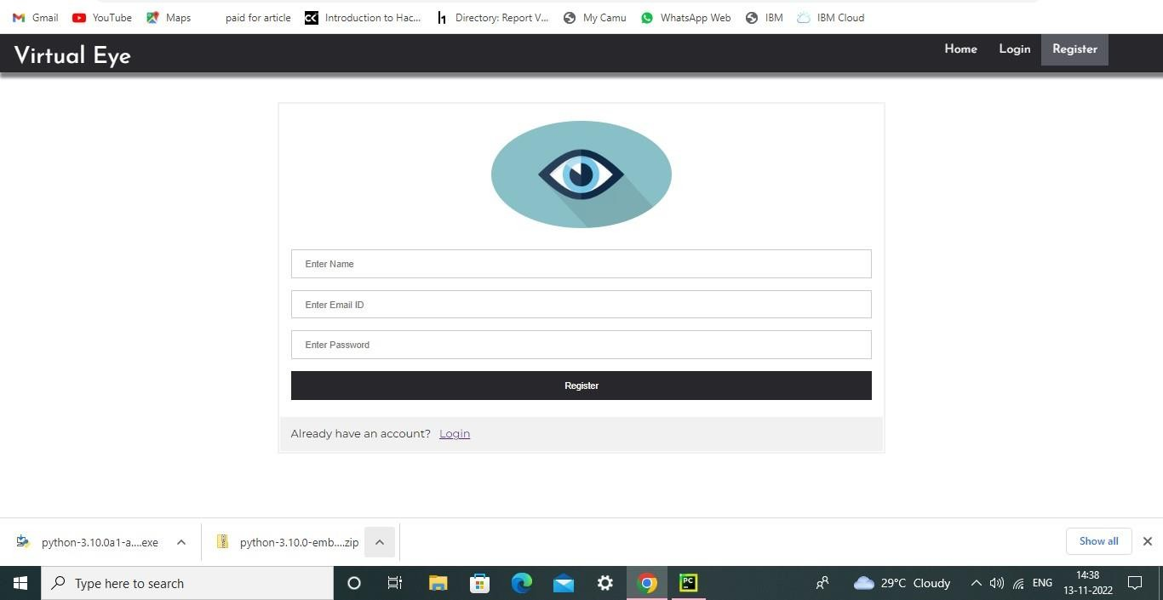

# login.html

<!DOCTYPE html>

<html >

<head>

<meta charset="UTF-8">

<meta name="viewport" content="width=device-width, initial-scale=1">

<title>Virtual Eye</title>

<link href='https://fonts.googleapis.com/css?family=Pacifico' rel='stylesheet' type='text/css'>

<link href='https://fonts.googleapis.com/css?family=Arimo' rel='stylesheet' type='text/css'>

<link href='https://fonts.googleapis.com/css?family=Hind:300' rel='stylesheet' type='text/css'>

<link href='https://fonts.googleapis.com/css?family=Open+Sans+Condensed:300' rel='stylesheet' type='text/css'>

<!link rel="stylesheet" href="{{ url_for('static', filename='css/style.css')

}}">

<link href='https://fonts.googleapis.com/css?family=Merriweather' rel='stylesheet'>

<link href='https://fonts.googleapis.com/css?family=Josefin Sans' rel='stylesheet'>

<link href='https://fonts.googleapis.com/css?family=Montserrat' rel='stylesheet'>

<style>

.header {

top:0; margin:0px; left: 0px; right: 0px;

}

.topnav {

position: fixed; background-color: #28272c; color: white;

box-shadow: 0px 8px 4px grey; overflow: hidden;

padding-left:20px;

font-family: 'Josefin Sans'; font-size: 2vw;

width: 100%; height:8%;

text-align: center;

overflow: hidden; background-color: #333;

}

.topnav-right a { float: left; color: #f2f2f2;

text-align: center; padding: 14px 16px; text-decoration: none; font-size: 18px;

}

.topnav-right a:hover { background-color: #ddd; color: black;

}

.topnav-right a.active { background-color: #565961; color: white;

}

.topnav-right { float: right; padding-right:100px;

}

.login{

margin-top:-70px;

}

body {

background-color:#ffffff; background-repeat: no-repeat; background-size:cover; background-position: 0px 0px;

}

.login{

margin-top:100px;

}

form {border: 3px solid #f1f1f1; margin-left:400px;margin-right:400px;} input[type=text], input[type=email],input[type=number],input[type=password] {

width: 100%; padding: 12px 20px;

display: inline-block; margin-bottom:18px; border: 1px solid #ccc; box-sizing: border-box;

}

button {

background-color: #28272c; color: white;

padding: 14px 20px; margin-bottom:8px; border: none; cursor: pointer; width: 100%;

font-weight:bold;

}

button:hover { opacity: 0.8;

}

.cancelbtn { width: auto;

padding: 10px 18px; background-color: #f44336;

}

.imgcontainer {

text-align: center; margin: 24px 0 12px 0;

}

img.avatar { width: 30%;

border-radius: 50%;

}

.container { padding: 16px;

}

span.psw { float: right;

padding-top: 16px;

}

/* Change styles for span and cancel button on extra small screens */ @media screen and (max-width: 300px) {

span.psw {

display: block; float: none;

}

.cancelbtn { width: 100%;

}

}

</style>

</head>

<body style="font-family:Montserrat;">

<div class="header">

<div style="width:50%;float:left;font-size:2vw;text-align:left;color:white; padding-top:1%">Virtual Eye</div>

<div class="topnav-right" style="padding-top:0.5%;">

<a href="{{ url_for('index')}}">Home</a>

<a class="active" href="{{ url_for('login')}}">Login</a>

<a href="{{ url_for('register')}}">Register</a>

</div>

</div>

<div id="login" class="login">

<form action="{{url_for('afterlogin')}}" method="post">

<div class="imgcontainer">

<img style="" src="https://cdn.digitalhealth.net/wp- content/uploads/2017/03/eye_image_generic_555.jpg" alt="Avatar" class="avatar">

</div>

<div class="container">

<input type="email" placeholder="Enter registered email ID" name="_id" required><br>

<input type="password" placeholder="Enter Password" name="psw"

required>

<button type="submit">Login</button><br>

{{pred}}

</div>

</form>

</div>

</body>

</html>

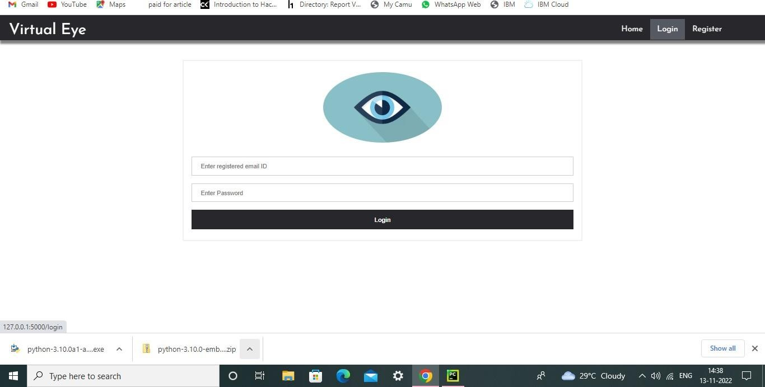

# prediction.html

<!DOCTYPE html>

<html lang="en">

<head>

<meta charset="UTF-8">

<meta http-equiv="X-UA-Compatible" content="IE=edge">

<meta name="viewport" content="width=device-width, initial-scale=1.0">

<!--Bootstrap -->

<link rel="stylesheet" href="https://maxcdn.bootstrapcdn.com/bootstrap/4.0.0/css/bootstrap.min.css" integrity="sha384- Gn5384xqQ1aoWXA+058RXPxPg6fy4IWvTNh0E263XmFcJlSAwiGgFAW/dAiS6JXm" crossorigin="anonymous">

<script src="https://code.jquery.com/jquery-3.2.1.slim.min.js" integrity="sha384- KJ3o2DKtIkvYIK3UENzmM7KCkRr/rE9/Qpg6aAZGJwFDMVNA/GpGFF93hXpG5KkN" crossorigin="anonymous"></script>

<script src="https://cdnjs.cloudflare.com/ajax/libs/popper.js/1.12.9/umd/popper.min.j s" integrity="sha384- ApNbgh9B+Y1QKtv3Rn7W3mgPxhU9K/ScQsAP7hUibX39j7fakFPskvXusvfa0b4Q" crossorigin="anonymous"></script>

<script src="https://maxcdn.bootstrapcdn.com/bootstrap/4.0.0/js/bootstrap.min.js" integrity="sha384- JZR6Spejh4U02d8jOt6vLEHfe/JQGiRRSQQxSfFWpi1MquVdAyjUar5+76PVCmYl" crossorigin="anonymous"></script>

<script src="https://kit.fontawesome.com/8b9cdc2059.js" crossorigin="anonymous"></script>

<link

href="https://fonts.googleapis.com/css2?family=Akronim&family=Roboto&display= swap" rel="stylesheet">

<link rel="stylesheet" href="../static/style.css">

<script defer src="../static/js/JScript.js"></script>

<title>Prediction</title>

</head>

<body>

<header id="head" class="header">

<section id="navbar">

<h1 class="nav-heading"></i>Virtual Eye</h1>

<div class="nav--items">

<ul>

<li><a href="{{ url_for('index')}}">Home</a></li>

<li><a href="{{ url_for('logout')}}">Logout</a></li>

<!-- <li><a href="#about">About</a></li>

<li><a href="#services">Services</a></li> -->

</ul>

</div>

</section>

</header>

<!-- dataset/Training/metal/metal326.jpg -->

</br>

<section id="prediction">

<h2 class="title text-muted">Virtual Eye- Life Guard for Swimming Pools to Detect Active Drowning</h1>

<div class="line" style="width: 900px;"></div>

</section>

</br>

<section id="about">

<div class="body">

<div class="left">

<p>

Swimming is one of the best exercises that helps people to reduce stress in this urban lifestyle. Swimming pools are found larger in number in the hotels, weekend tourist spots and barely people have in their house backyard. Beginners, especially often feel it difficult to breathe under water and causes breathing trouble which in turn cause a drowning accident. Worldwide, drowning produces a higher rate of mortality without causing injury to children. Children under six of their age are found to be suffering the highest drowning mortality rates worldwide..Such kinds of deaths account for the third cause of unplanned death globally, with about 1.2 million cases yearly.

</p>

</div>

<div class="left">

<div class="prediction-input">

<img class="d-block w-100" src="../static/img/second.jpg" alt="Second

slide">

</br>

<form id="form" action="/result" method="post"

enctype="multipart/form-data">

<input type="submit" class="submitbtn" value="Click Me!

For a Demo">

</form>

</div>

<h5 style="text-color:Red">

<b style="text-color:Red">{{prediction}}<b>

</h5>

</div>

</div>

</section>

</br></br>

<section id="footer">

<p>Copyright © 2021. All Rights Reserved</p>

</section>

</body>

</html>

# logout.html

<!DOCTYPE html>

<html >

<head>

<meta charset="UTF-8">

<meta name="viewport" content="width=device-width, initial-scale=1">

<title>Virtual Eye</title>

<link href='https://fonts.googleapis.com/css?family=Pacifico' rel='stylesheet' type='text/css'>

<link href='https://fonts.googleapis.com/css?family=Arimo' rel='stylesheet' type='text/css'>

<link href='https://fonts.googleapis.com/css?family=Hind:300'

rel='stylesheet' type='text/css'>

<link href='https://fonts.googleapis.com/css?family=Open+Sans+Condensed:300' rel='stylesheet' type='text/css'>

<link href='https://fonts.googleapis.com/css?family=Merriweather' rel='stylesheet'>

<link href='https://fonts.googleapis.com/css?family=Josefin Sans' rel='stylesheet'>

<link href='https://fonts.googleapis.com/css?family=Montserrat' rel='stylesheet'>

<style>

.header {

}

top:0; margin:0px; left: 0px; right: 0px; position: fixed;

background-color: #28272c; color: white;

box-shadow: 0px 8px 4px grey; overflow: hidden;

padding-left:20px;

font-family: 'Josefin Sans'; font-size: 2vw;

width: 100%; height:8%;

text-align: center;

.topnav { overflow: hidden; background-color: #333;

}

.topnav-right a { float: left; color: #f2f2f2;

text-align: center; padding: 14px 16px; text-decoration: none; font-size: 18px;

}

.topnav-right a:hover { background-color: #ddd; color: black;

}

.topnav-right a.active { background-color: #565961; color: white;

}

.topnav-right { float: right; padding-right:100px;

}

.login{

margin-top:-70px;

}

body {

background-color:#ffffff; background-repeat: no-repeat; background-size:cover; background-position: 0px 0px;

}

.main{

margin-top:100px; text-align:center;

}

form { margin-left:400px;margin-right:400px;}

input[type=text], input[type=email],input[type=number],input[type=password] { width: 100%;

padding: 12px 20px; display: inline-block; margin-bottom:18px; border: 1px solid #ccc; box-sizing: border-box;

}

button {

background-color: #28272c; color: white;

padding: 14px 20px; margin-bottom:8px; border: none; cursor: pointer; width: 20%;

}

button:hover { opacity: 0.8;

}

.cancelbtn { width: auto;

padding: 10px 18px; background-color: #f44336;

}

.imgcontainer {

text-align: center; margin: 24px 0 12px 0;

}

img.avatar { width: 30%;

border-radius: 50%;

}

.container { padding: 16px;

}

span.psw { float: right;

padding-top: 16px;

}

/* Change styles for span and cancel button on extra small screens */ @media screen and (max-width: 300px) {

span.psw {

display: block; float: none;

}

.cancelbtn { width: 100%;

}

}

</style>

</head>

<body style="font-family:Montserrat;">

<div class="header">

<div style="width:50%;float:left;font-size:2vw;text-align:left;color:white; padding-top:1%">Virtual eye</div>

<div class="topnav-right" style="padding-top:0.5%;">

<a href="{{ url_for('home')}}">Home</a>

<a href="{{ url_for('login')}}">Login</a>

<a href="{{ url_for('register')}}">Register</a>

</div>

</div>

<div class="main">

<h1>Successfully Logged Out!</h1>

<h3 style="color:#4CAF50">Login for more information<h3>

<a href="{{ url_for('login') }}"><button type="submit">Login</button></a>

</form>

</div>

</body>

</html>

